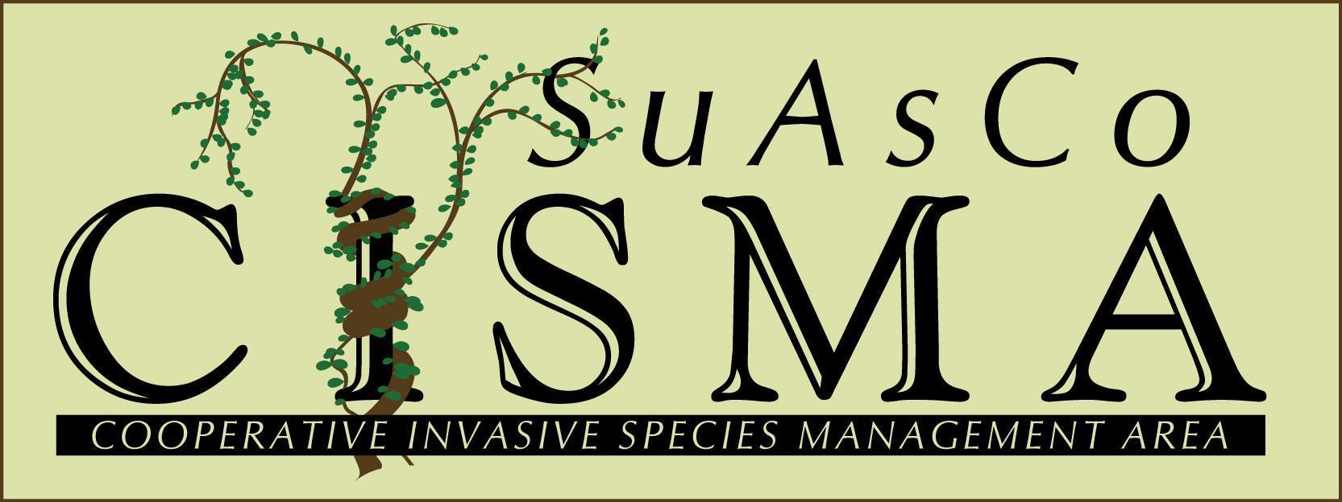

**SuAsCo Cooperative Invasive Species Management Area (CISMA)** **REQUEST FOR PROPOSALS**

The Steering Committee of the SuAsCo CISMA has received $7,000 from the Sudbury-Assabet-Concord Wild & Scenic River Stewardship Council (RSC) to fund one or more invasive species control projects. We are seeking proposals from CISMA Partner organizations for projects that would directly benefit the Sudbury, Assabet, and/or Concord rivers by either eradicating/managing applicable priority species or by supporting educational outreach efforts. The watershed-wide priority species are listed in Table 1. Projects must occur within the Sudbury-Assabet-Concord (SuAsCo) watershed. The RSC works to protect the resource values of these three rivers, including ecology, scenery, recreation, history and literature. Please describe how your project will help to meet the RSC’s objectives. We encourage proposals to include collaboration among multiple landowners, and/or recruiting and training a group of volunteers (or making use of existing volunteers), but these aspects are not required. Projects that directly impact the rivers or associated wetlands will be given priority. If your project does not directly impact one of the rivers or associated wetlands please describe how this work will benefit the watershed.

Using the application below, proposals should include details on project objectives and methods, discussion of how the project relates to the targeted objectives, a project timeline, and a detailed budget. Proposals must include a process for evaluating effectiveness of the control effort and demonstrate a capacity for long-term monitoring and follow-up. Proposals should be no more than two pages plus supporting materials such as maps and letters of support. If funding is awarded the awardee is required to either host a walk or presentation on the work they did.

To apply, email proposals to Kristin O'Brien at kobrien@svtweb.org with the subject “SuAsCo CISMA Grant Application”. **Application deadline is 5:00 pm, December 20, 2024**. Grant recipients will be asked to submit a final report by July 15, 2025 (an extension can be requested).

Questions can be directed to Kristin at kobrien@svtweb.org or at 978-443-5588 ext. 135.

To see previously-funded projects go to: <https://cisma-suasco.org/projects/> [.](http://www.cisma-suasco.org/projects/grants/currentgrants) For more information about the SuAsCo Wild and Scenic River or the RSC, visit [http://www.sudbury-assabet-concord.org/.](http://www.sudbury-assabet-concord.org/)

All applications will be reviewed by the SuAsCo CISMA Steering Committee and announced after the January 2025 Steering Committee meeting. The Steering Committee will strive to allocate funding by consensus. However, if a vote is required, Steering Committee members whose organizations have applied for funding will not be able to participate in discussions and decisions regarding allocation of funds.

**Table 1. Watershed-Wide Priority Species**

|  |  |  |
| --- | --- | --- |
| **Watershed-wide early detection species** |  | **Watershed-wide species of ongoing concern** |
| Amur cork tree  Black jetbead  Brazilian water weed  Broad-leaved pepperweed  Callery pear  Chinese silvergrass  Creeping buttercup  European alder  Fig Buttercup  Giant hogweed  Hydrilla  Japanese stiltgrass  Kudzu  Mile-a-minute vine  Mugwort  Narrow-leaf bittercress  Porcelain Berry  Rusty Willow  Wall lettuce  Wild Chervil  Wineberry |  | Autumn olive  Black swallowwort  Burning bush  Bush honeysuckle  Common reed/Phrag  Eurasian watermilfoil  Garlic mustard  Glossy Buckthorn  Japanese barberry  Japanese knotweed  Multiflora rose  Invasive bittersweet  Purple loosestrife  Spotted knapweed  Tree-of-heaven  Water chestnut |

**SuAsCo CISMA Project Proposal Application – 2025**

**Organization Name: Total Funding Request: $________**

**Total Project Cost: $________**

**CISMA Signatory Partner: Yes No**

**Has your organization ever received CISMA Grant Funds: Yes No**

**If Yes, when_____________**

**Project Name:**

**Contact person: Title:**

**Address: Town:**

**Email address: Telephone:**

**Proposal Information:**  *Please note this RFP has been revised from previous years*. You can type directly into this document. Applications should be no more than 2 pages plus budget. Letters of support and additional pertinent materials may be included, though not required, in the application submission. Please submit the application and supporting materials via email to Kristin O’Brien (kobrien@svtweb.org) with the subject “SuAsCo CISMA Grant Application”.

Specific Project Goals:

How the Project Meets RSC Goals (described above):

Site Description and Context:

Description of Proposed Methods for Invasive Plant Control:

Description of how the site will be monitored and evaluated for success:

If Educational, describe work to be completed and how the project will help educate others:

Who is the target audience for educational materials?

Would you be willing to accept partial funding?

If applicable, have you obtained permits or written approval from the necessary departments?

**Case Study Submission Requirement:**

Grant recipients will be required to provide case study information for the CISMA web site (<https://cisma-suasco.org/project/>). The case study should include the information below and can be used as a guide while writing your proposal. If awarded you will be required to present at the CISMA Fall meeting or provide a site visit to highlight your work.

1. **Description of Program/Project:** Identify and explain:
   * The goal(s) and need for your project.
   * How the project meets the intent of the RSC resource values for the Sudbury, Assabet, or Concord rivers, including ecology, scenery, recreation, history and literature. If your project does not directly impact one of the rivers or associated wetlands please describe how this work will benefit the watershed.
   * Identify the target priority invasive species, include species latin name
   * Identify restoration activities including native plant species you may be planting
2. **Specific activities:**

* Concisely list and explain all project tasks and deliverables for each task.
* Include a timeline, arranged by task, indicating start date, date of task completion and submission of deliverable(s) date.

1. **Evaluation:**  Please provide details on the evaluation process and matrices that will be used to gauge success (how well project implementation met the anticipated outcomes/goals) and how this will be reported to the CISMA.
2. **Other:** Provide any other information you feel would be relevant and not covered above.
3. **Budget:** Complete the following budget table with budget breakdown requirements, (add additional tasks if needed).

|  |  |  |  |  |  |
| --- | --- | --- | --- | --- | --- |
| **Category** | **Project tasks/items** | **Amount requested** | **Funding match  amount** | **In-kind match amount** | **Match details** |
| Contractual services | | | | | |
| *Example:* | *Consultant to develop invasive plant management plan* | *$3,500* | *$* | *$600* | *Project oversight by team lead.*  *(20 hours x $30/hour x 1 person)* |
|  |  | $ | $ | $ |  |
|  |  | $ | $ | $ |  |
| Supplies and materials | | | | | |
| *Example:* | *Signs, posts, hardware* | *$1,800* | *$* | *$360* | *Sign installation by Department of Public Works. (6 hours x $30/hour x 2 people)* |
|  |  | $ | $ | $ |  |
|  |  | $ | $ | $ |  |
| Personnel | | | | | |
| *Example:* | *Pollinator garden planting* | *$* | *$* | *$2,880* | *Volunteer labor. (8 hours x $30/hour x 12 people)* |
|  |  | $ | $ | $ |  |
|  |  | $ | $ | $ |  |
| **TOTALS** |  | $ *5,300* | $ 0 | *$ 3,840* |  |

**TOTALS:** CISMA $________ Grants $__________ In-Kind $_________ Other $_______

**Budget Narrative**: Provide additional clarifying information about the project budget. Applicants are encouraged to provide the CISMA with a prioritized list of project tasks. This will help inform decisions should the CISMA opt to fund only select project tasks. Attach any quotes you are itemizing in your budget